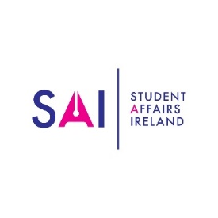
Institutional Membership Form
1 January 2019 – 31 December 2019

Membership Rate: Please tick as appropriate:
Numbers | € | Tick
1 to 4 members | 150 | ☐
5 to 9 members | 250 | ☐
10 – 15 members | 400 | ☐
16 or more members | 500 | ☐

Please list the names and contact details of all members you wish to include in your Institutional SAI Membership. Application for Institutional Membership must have a Lead Member/Contact person.
Lead Member/Contact | Institution | Title/Department | Email | Contact Number

Members Name | Title | Area of Professional Interest | Email | Contact Number
Payment Method & Total
Cheque/Bank Draft ☐ | Send Invoice ☐ | Send Receipt ☐ | PO Reference Number: | Total €

Please make cheques/Bank Drafts/transfers payable to Student Affairs Ireland. SAI Bank Account Your remittance should be sent to: Dr Dan Collins, Academic Administration & Student Affairs Manager, Cork Institute of Technology, Rossa Avenue, Bishopstown, Cork.
Please ensure that you give a reference (invoice number) so that payment can be traced back to you.

Student Affairs Ireland, Bank of Ireland, Trinity Branch, 2 College Green, Dublin 2. Branch Code: 90-00-17. Account Number: 22021021. Swift Code: BOFIIE2D. IBAN: IE98 BOFI 90001722021021

